

Overview

The Solutionz RMM Agent is uses a Protectli Vault V1410, features the Intel® Celeron® Processor N5105 with 8GB soldered (fixed) DDR4 memory and 32GB onboard eMMC. It also includes three additional M.2 slots for optional NVMe SSD storage, WiFi, and LTE modules. The V1410 is equipped with four Intel® I226-V RJ-45 Ethernet ports, supporting up to 2.5 Gigabit ethernet connectivity with backwards compatibility.

The operating system is Ubuntu 24.04.3, custombuilt and performanceoptimized to seamlessly support the Solutionz RMM Platform.

Protectli Vaults utilize Intel components ensuring persistent compatibility with a wide range of operating systems (OS) and applications. The "V" series Vaults feature a fanless, all-aluminum chassis design, allowing for efficient heat dissipation from the CPU and other components without any moving parts or additional power requirements.

Technical Specifications

Model | V1410
Description | 4x 2.5G Network Port Fanless Appliance
Processor | Intel® Celeron® Processor N5105 (64 Bit, 2.0GHz, Turbo 2.9GHz, 4M L3 Cache)
Processor Cores | 4
Processor Threads | 4
Processor Capabilities | AES-NI
Processor Capabilities | Intel® Vt-x, Vt-d
Network | 4x Intel® I226-V 2.5G Ethernet, RJ-45
Video / Graphics | Intel® UHD Graphics, 1x HDMI 2.0
Audio | Audio over HDMI
Memory | 1x 8GB LPDDR4-2933, Soldered
Operating System | Linux - Ubuntu 24.04.3 LTS (minimized CLI version)
Chassis | Fanless, Aluminum, Gray
Chassis Dimensions | w/ feet: 5.6 x 4.8 x 2.3in. (142.1 x 121.0 x 57.7mm)  w/o feet: 5.6 x 4.8 x 2.1in. (142.1 x 121.0 x 55.1mm)

External Interfaces

Front Panel Configuration
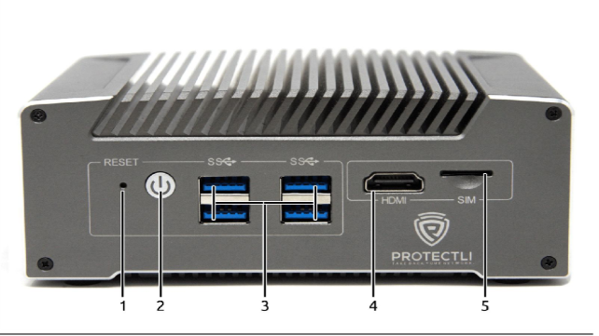

Item # | Object | Label | Description
1 | Reset Button (Recessed) | RESET | An ACPI reset button.
2 | Power Button |  | Pressing the Power Button will power the unit on and illuminate with a blue LED.  In OSes configured to handle ACPI signals, pressing the power button initiates a shutdown.  Pressing and holding the Power Button for 5 seconds will force the unit to power off.
3 | USB Type-A Ports |  | Four USB 3.2 Gen 1† Type-A ports. (Maximum theoretical throughput of 5000Mbps [~500MBps])
4 | HDMI Port | HDMI | Video and audio output via HDMI 2.0.
5 | Onboard Micro (3FF) SIM Slot | SIM | Access to an onboard Micro (3FF) SIM slot for providing a SIM card to an optional internal cellular modem.

Rear Panel Configuration

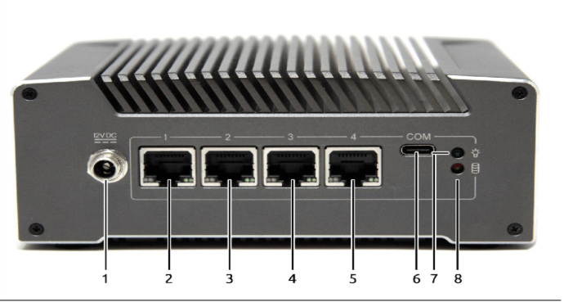

Item # | Object | Label | Description
1 | Power Supply Connector |  | 12V DC locking collar connector for the included 48W external power supply. Positive rail is the tip, negative is sleeve.  Barrel dimensions: 5.5mm x 2.5mm
2 | Ethernet Ports | 1, 2, 3, 4 | Four (4) 10/100/1000/2500 Mbps Intel® I226-V ethernet ports. The bottom right LED emits solid green when connected at any speed.
3 | Type-C Serial Console Port | COM | RS-232 serial communications via FTDI FT232RQ UART, exposed through USB 2.0 Type C connector. Default port settings:  - 115200 baud  - No parity  - 8 data bits  - 1 stopbit
4 | Power Indicator LED |  | LED emits solid green when the device is powered on.
5 | Data Activity LED |  | LED emits red when data activity is detected over the NVMe interface.

Dimension View 