

Overview

The Solutionz RMM Agent uses a Protectli Vault V1210, features the Intel® Celeron® Processor N5105 with 4GB soldered (fixed) DDR4 memory and 32GB onboard eMMC. It also includes three additional M.2 slots for optional NVMe SSD storage, WiFi, and LTE modules. The V1210 is equipped with two Intel® I226-V RJ-45 Ethernet ports, supporting up to 2.5 Gigabit ethernet connectivity with backwards compatibility.

The operating system is Ubuntu 24.04.3, custom‑built and performance‑optimized to seamlessly support the Solutionz RMM Platform.

Protectli Vaults utilize Intel components ensuring persistent compatibility with a wide range of operating systems (OS) and applications. The "V" series Vaults feature a fanless, all-aluminum chassis design, allowing for efficient heat dissipation from the CPU and other components without any moving parts or additional power requirements.

Technical Specifications

Model |  | V1210
Description |  | 2x 2.5G Network Port Fanless Appliance
Processor |  | Intel® Celeron® Processor N5105 (64 Bit, 2.0GHz, Turbo 2.9GHz, 4M L3 Cache)
Processor Cores |  | 4
Processor Threads |  | 4
Processor Capabilities |  | AES-NI
 |  | Intel® Vt-x, Vt-d
Network |  | 2x Intel® I226-V 2.5G Ethernet, RJ-45
Video / Graphics |  | Intel® UHD Graphics, 1x HDMI 2.0
Audio |  | Audio over HDMI
Memory |  | 1x 4GB LPDDR4-2933, Soldered
Operating System |  | Linux - Ubuntu 24.04.3 LTS (minimized CLI version)
Chassis | Fanless, Aluminum, Gray
Chassis Dimensions | w/ feet: 5.6 x 4.8 x 2.3in. (142.1 x 121.0 x 57.7mm)  w/o feet: 5.6 x 4.8 x 2.1in. (142.1 x 121.0 x 55.1mm)

External Interfaces

Front Panel Configuration

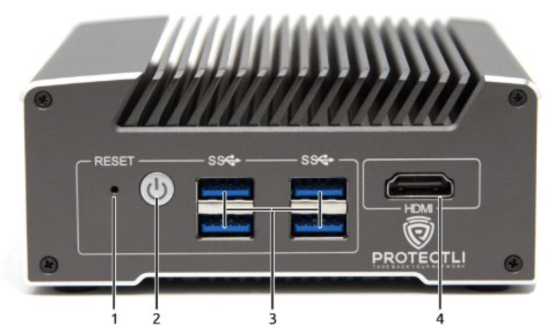

Item # | Object | Label | Description
1 | Reset Button (Recessed) | RESET | An ACPI reset button.
2 | Power Button |  | Pressing the Power Button will power the unit on and illuminate with a blue LED.  In OSes configured to handle ACPI signals, pressing the power button initiates a shutdown.  Pressing and holding the Power Button for 5 seconds will force the unit to power off.
3 | USB Type-A Ports |  | Four USB 3.2 Gen 1† Type-A ports. (Maximum theoretical throughput of 5000Mbps [~500MBps])
4 | HDMI Port | HDMI | Video and audio output via HDMI 2.0 port.

†USB-IF naming standard for USB transfer rates: “USB 3.2 Gen 1” is the equivalent and current name for “USB 3.2 Gen 1”, “USB 3.1 Gen 1”, and “USB 3.0”. Older kernels and operating systems may not report the most recent naming convention. For a full linguistic deep dive, please see 3.1 and 3.2 Specification Language Usage Guidelines from USB-IF.

Rear Panel Configuration

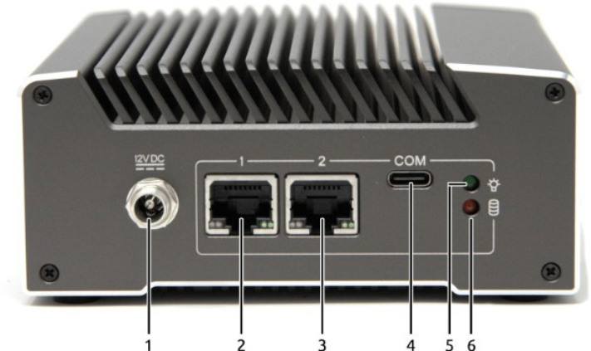

Item # | Object | Label | Description
1 | Power Supply Connector |  | 12V DC locking collar connector for the included 48W external power supply. Positive rail is the tip, negative is sleeve.  Barrel dimensions: 5.5mm x 2.5mm
2 | Ethernet Ports | 1, 2 | Two (2) 10/100/1000/2500 Mbps Intel® I226-V ethernet ports. The bottom right LED emits solid green when connected at any speed.
3 | Type-C Serial Console Port | COM | RS-232 serial communications via FTDI FT232RQ UART, exposed through USB 2.0 Type C connector. Default port settings:  - 115200 baud  - No parity  - 8 databits  - 1 stopbit
4 | Power Indicator LED |  | LED emits solid green when the device is powered on.
5 | Data Activity LED |  | LED emits red when data activity is detected over the NVMe interface.

Side Panel Features
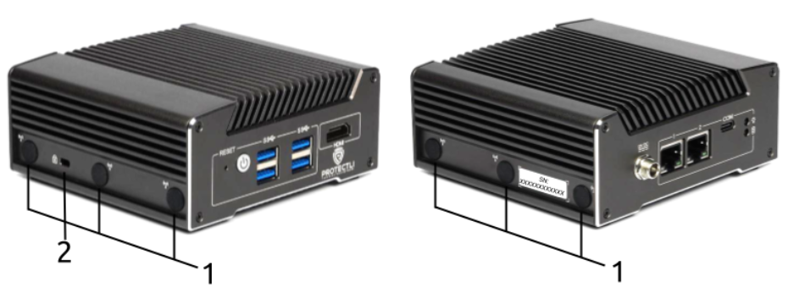

Item # | Object | Label | Description
1 | Antenna Ports |  | Six antenna ports, three on the left and three on the right of the unit, for mounting radio antennas (e.g. WiFi, LTE). The ports are covered by plugs while not in use.
2 | Kensington Security Slot |  | A standard anti-theft locking slot, Kensington Security Lock compatible.

Dimension View 