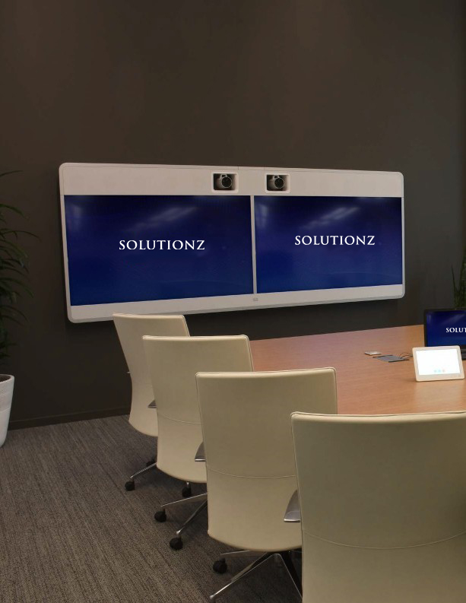

INTEGRATING THE BEST

AUDIO-VISUAL TECHNOLOGY FOR TECH GIANT BLACKBAUD

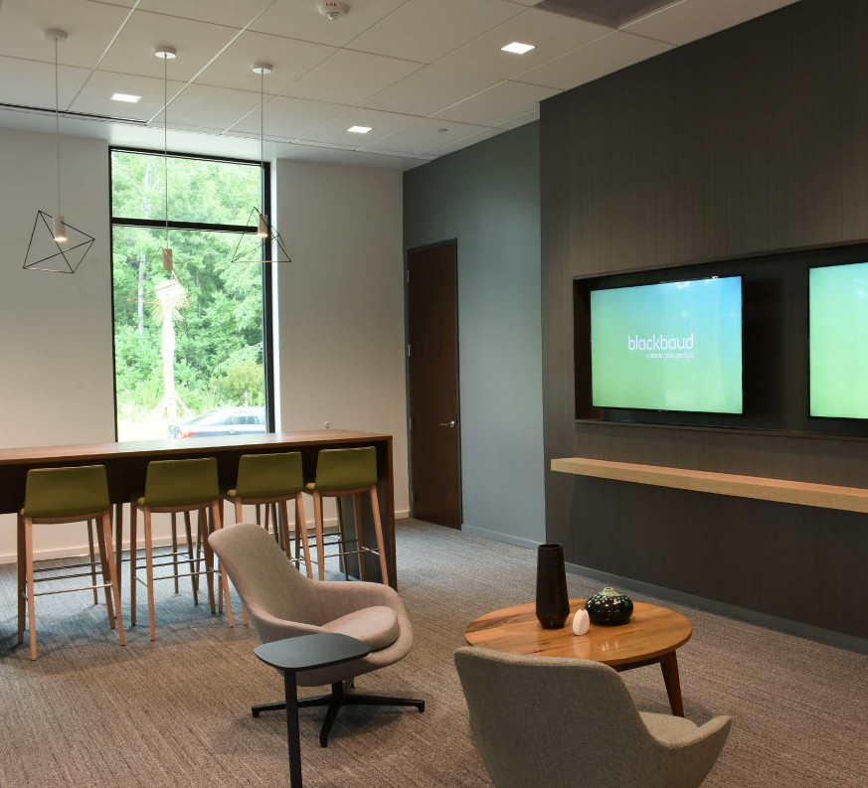

POWERING THE DIGITAL LANDSCAPE

FOR SOCIAL GOOD

One of the leading cloud software companies in the world, Blackbaud has been at the forefront of technology to assist projects of communal welfare. The company delivers data intelligence, cloud services, and other technical expertise that enable change-makers to effectively interact with one another and drive collective improvement in their societies.
Powering more than 40,000 customers in 60 different countries around the world, Blackbaud is digitally transforming the social welfare landscape. Solutionz Inc. had the opportunity to partner with them in setting up a new state-of-the-art headquarters in Charleston, SC.

© 2020 Solutionz Inc. www.solutionzinc.com 888.815.6128
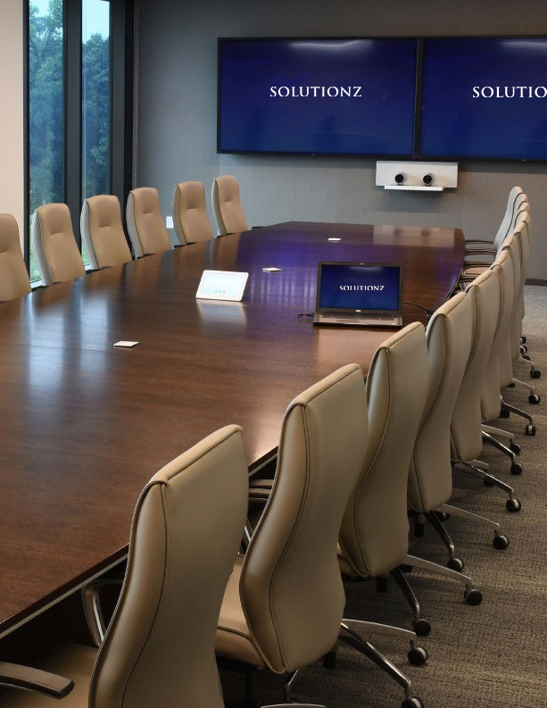

EFFECTIVE COMMUNICATION IS KEY

As a leading tech player serving non-profit organizations and welfare groups, Blackbaud keeps its solutions user-friendly.
With locations around the world, Blackbaud’s development
team is often scattered across multiple sites, making effective communication and collaboration extremely important.
The company wanted its new headquarters to be a communication-friendly place without any connectivity issues. Single-touch quick-access was needed to upgrade, yet simplify, the communication process. From the large conference halls to the smaller huddle spaces, simplicity was a key design element the company required.
Connectivity across locations was vital. Blackbaud wanted a one-touch Cisco video setup linked to Outlook and Webex. The idea was to have a real-time connectivity mechanism whereby all team members using Outlook could simply book a meeting.
The system would take care of connectivity between two or more team rooms, whether in one building or multiple locations around the globe.
The other aim was to make it easy to come together as a large team in this new facility and include other remote locations.
The company converted its cafeteria space with the huge video wall into a town hall environment for an “all hands” meeting. All locales now join the conference via the easy-to-use video conferencing system. The entire Blackbaud team is included in each state-of- the-business session, allowing the groups to foster a sense of company togetherness.

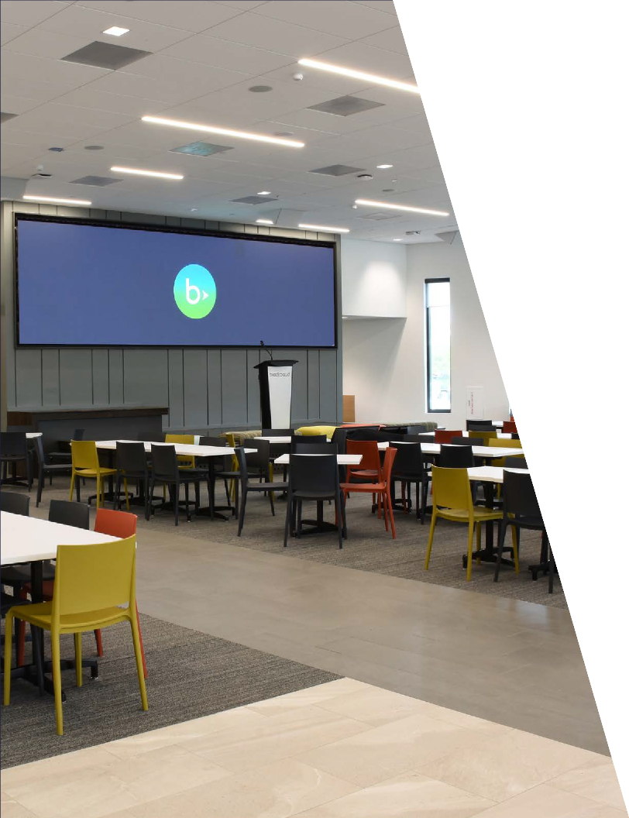

THE SOLUTION BY SOLUTIONZ INC.

Solutionz Inc. set about developing an integration plan for Blackbaud’s meeting and connectivity goals. Our engineers improved upon the legacy system to create a structure that was better suited to Blackbaud’s needs.
To the delight of the Blackbaud team, Solutionz was able to rectify the previous programming in the divisible training rooms and make the operations run the way they were originally intended. Considering the magnitude of the project, effective coordination with subcontractors had become quite a challenge. Solutionz Project Managers worked to fill the gaps in communication and coordination to ensure that all requirements were met.

COMMUNITY ENGAGEMENT

One of the goals of Blackbaud as a company is to actively engage with the communities where it has office locations. Blackbaud is always ready to lend a hand and has been an integral part of the Charleston, SC community by allowing local non-profits to use its new high-tech space for large meetings.
Because outside groups would be regular users of its new facility, this was another reason for Blackbaud to make the communication and connectivity systems very high-end yet straightforward and easy to use. Here again, Solutionz was instrumental in facilitating the achievement of our client’s goals.

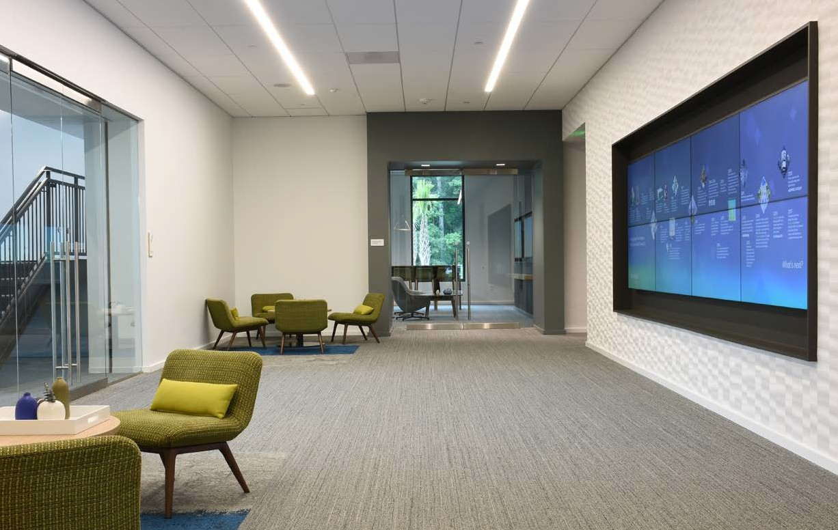

SOLUTIONZ INC.

Solutionz Inc. has been providing highly effective AV and communication solutions to small and large businesses, government entities, major corporations, and educational institutions for more than 25 years.
Solutionz is one of the largest service providers in the American Southeast. Their extensive partnerships with other technology firms enable them to have a national as well as global outreach.

MAKING COMMUNICATION SIMPLE AND FUN

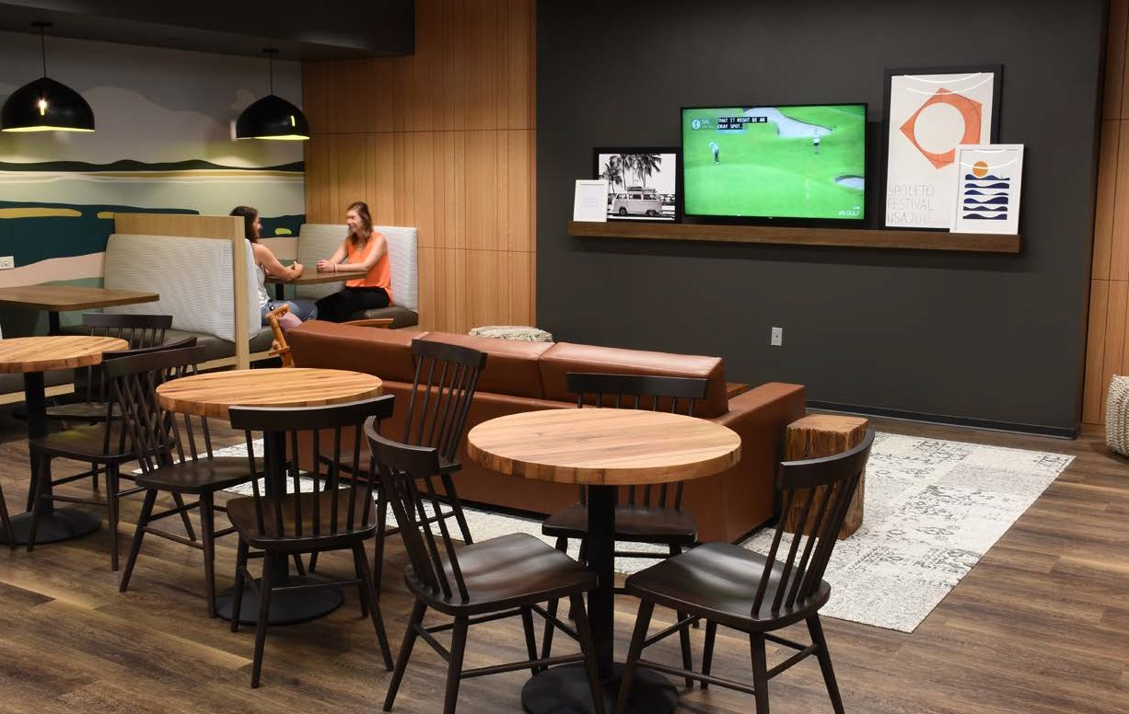
Solutionz understands the importance of technology for quality meetings, presentations, and training rooms and the difference these investments can make to the bottom line. To that end, Solutionz aims to deliver the most effective and efficient technology solutions.
Established as a forward- thinking company dedicated to staying on top of the latest technology advancements, our company credits its innovation and growth mindset for its ability to deliver high-quality services and systems support nationwide. Whether clients need video conferencing facilities to scale, integrated presentation networks, or interactive collaboration tools to connect remote team members in an instant, Solutionz provides reliable and effective communication and collaboration solutions and strives to be the ideal audiovisual partner.

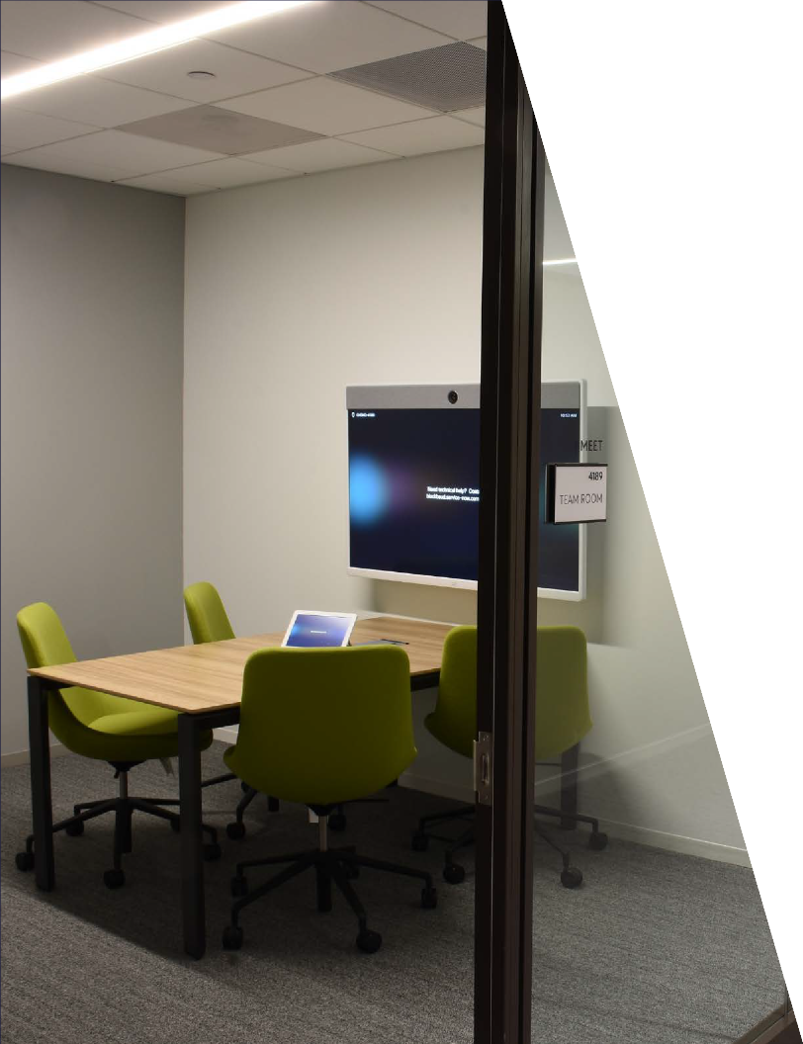

SOLUTIONZ: A TRUSTED PARTNER

Blackbaud needed a top-notch systems integrator that could meet the scope of their intended meeting room technology and would be responsive during the construction process. Solutionz Inc. answered the call.
Solutionz Inc. was able to provide large-market AV services in the Charleston, SC area. With regional offices in the proximity to the project, and its dependable team, Blackbaud learned to count on Solutionz as a valued contributor throughout the construction process.

Solutionz always made sure the customer was taken care of regardless of who was responsible in the contract.
Otto Orr, Blackbaud, Charleston, SC.

SOLUTIONS

Solutionz implemented an AV solution centered on Blackbaud’s preferred platform. The technology was scaled throughout the new building’s spaces creating a ubiquitous user experience throughout the facility.

Solutionz provided:

- Projection and Display Technology
- Audio Enhancement
- Room Control
- Digital signage throughout the facility
- Customer Innovation Video Wall
- Large-scale “all-hands” meeting area designed to be operated by in-house tech staff
- Huddle Rooms
- One-touch videoconferencing systems

© 2020 Solutionz Inc. | www.solutionzinc.com | 888.815.6128

